
CSI4901 – Capstone Project
Fall Semester 2024-2025
Zeroth Review
HOSPITAL MANAGEMENT SYSTEM USING MERN STACK

Name: B Sahithya
Reg No: 20MIC0007
Guide: Dr Manoov R

ONE PAGE WRITEUP
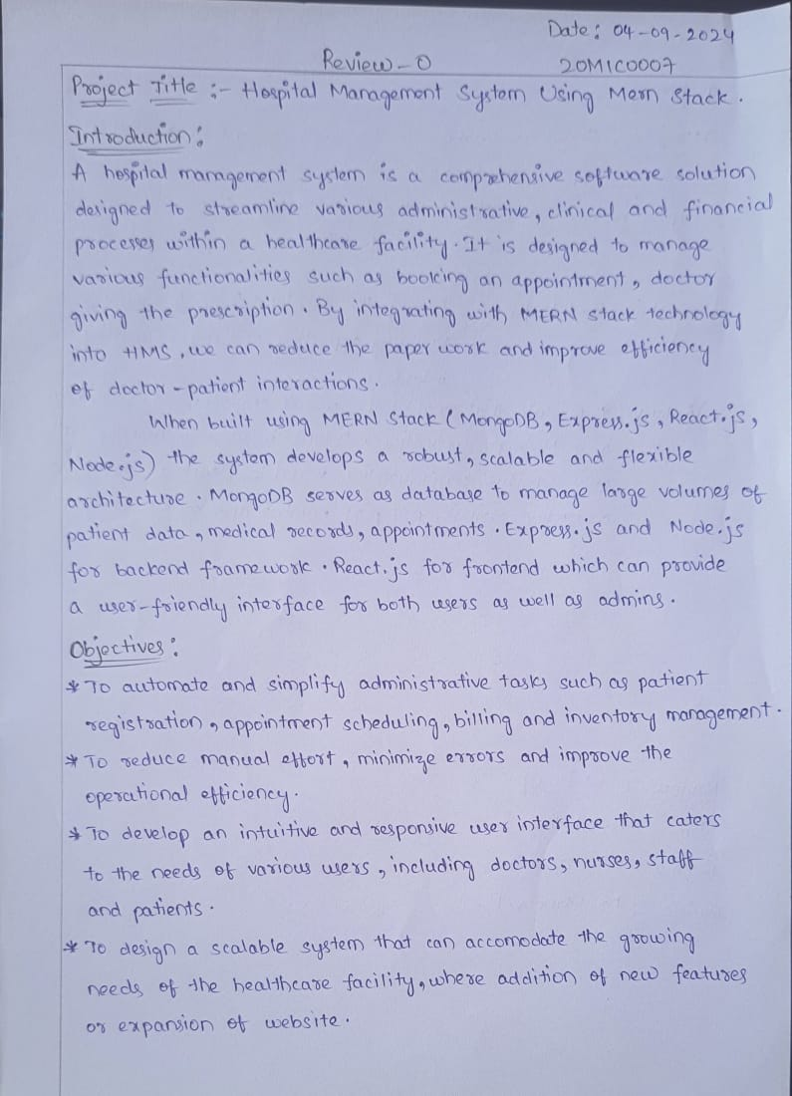
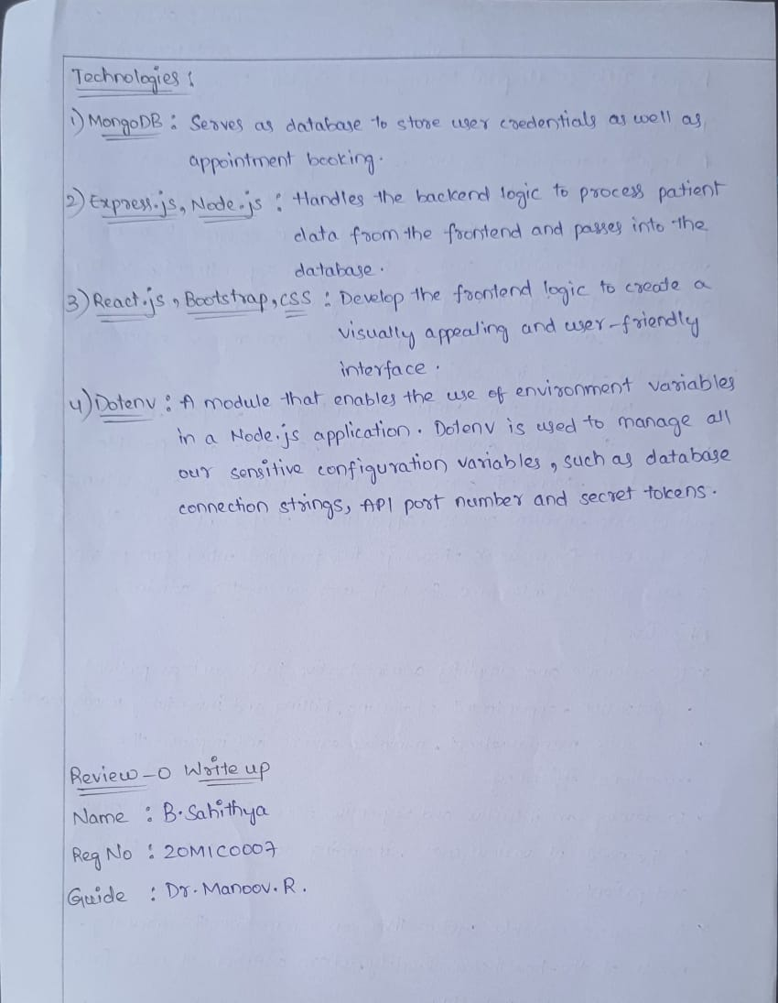

BASE PAPER
Wang, M., Le, Y., & Yu, C. H. (2023, December). MedCare4Home: A Mobile Medical System for Families. In 2023 IEEE International Conference on E-health Networking, Application & Services (Healthcom) (pp. 259-264). IEEE.
TIMELINE CHART
